The Grantown Society SCIO
Annual Report June 2025

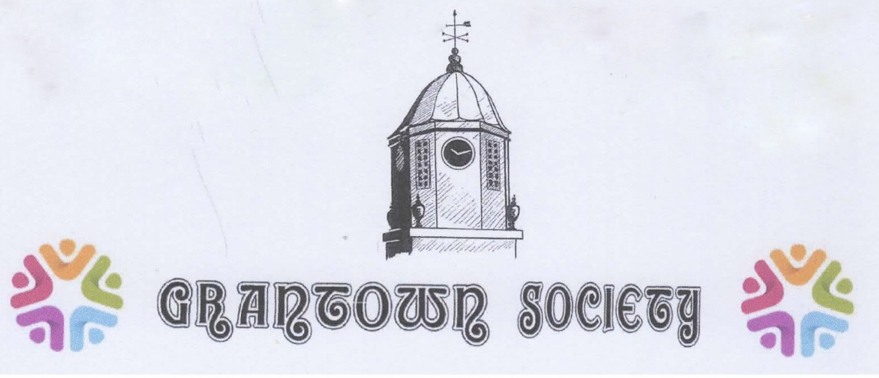

Patron: Viscount Reidhaven

Reporting Period: 1 July 2024 – 30 June 2025

to be presented at AGM: 19 September 2025
Not including the Audited accounts and OSCR report

1. Introduction
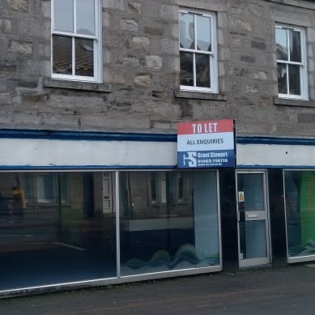
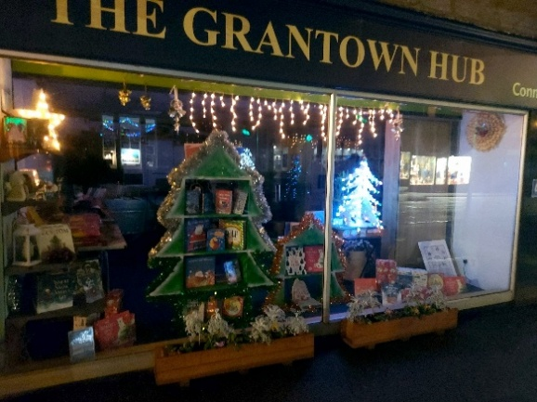
For the Grantown Society, 24/25 was a momentous and, at the same time, a challenging year. It was the year we turned derelict High Street eyesore premises into a vibrant community space.
It was the year we opened and ran the Grantown hub, the year we began as a “digital inclusion” organisation, the year we ran two music festivals and a festival of cycling. It was also the year in which we lost our broadband, our website and IT support.

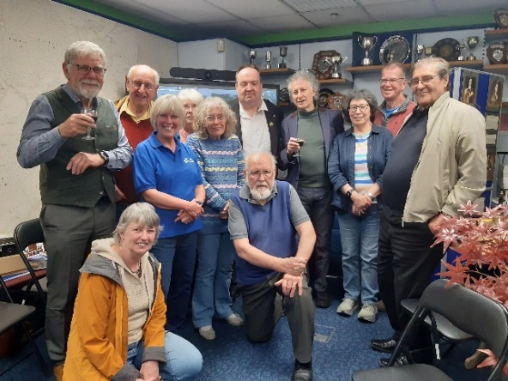
Nevertheless, with ongoing support from the Scottish Land Fund the Government Place-based Digital inclusion programme, Berryburn Community Fund, Highland Broadband, our local community and sponsors, our members and a fantastic team of volunteers we are overcoming the barriers and, whilst deviating from our business plan, have had a successful year in which there have been many highlights. Year two will also bring its challenges. There are, nevertheless, great opportunities, and we have started the year with vision and optimism.

2. Charitable Objectives
The Grantown Society was originally formed in June 1974 as a “Local History Society”. Through time, because of the range of its activities, it has come to be known also as a “Community Heritage Organisation” yet with the same objectives. In April 2020 it was registered as a SCIO (Scottish Charitable Incorporated Organisation) number SC050104. The Society’s core geographic community area is PH26 3.
The charitable objects are:
The advancement of:
- education of the Community about its environment, culture, heritage and /or history.
- citizenship or community development.
- arts, heritage, culture or science through appropriate media.
- environmental protection or improvement including preservation, sustainable development and conservation of the natural environment, the maintenance, improvement or provision of environmental amenities for the Community and/or the preservation of buildings or sites of architectural, historic or other importance to the Community.

Working objectives/

Working objectives
Based on our business plan and community surveys, and with respect to the community ownership of 2 High Street, these translate into three objectives :
- Creating a warm and welcoming place where people can drop in to learn more about Grantown's history and heritage and what is happening in the local area.
- Providing modern co-working and meeting room space which will have high-speed broadband and excellent facilities, supporting Grantown to be an attractive place to visit, work and live.
- Supporting and promoting Grantown, its shops and its businesses and attracting more people to Grantown’s High Street.

Meeting our objectives
On 16th July planning permission was granted for the Society use of the building and work went ahead for a “soft opening” of the “Grantown Hub” on August 5th 2024.
A warm and welcoming place
During this year we have been building community confidence in The Hub and what it offers. Whilst in mid winter, the heating installed so far proved inadequate, the atmosphere has certainly been warm and welcoming as evidenced by comments in our visitors’ book.

“What a wonderful welcoming space and all the volunteers are so friendly and helpful.” (Robert Arbuthnot)

In the Spring, following the loss of IT media, there were significant delays to our progress for the provision of and access to online information. It also resulted in much hard work rectifying the situation and rebuilding local trust. We are confident now of large (though not total) community support - if not yet the level of involvement we aim for.

Co-working and meeting space
In October, thanks to the Scottish Land Fund and the Berryburn Trust, a glass partition was fitted, defining the space and providing instant improvement. The “Internet Lounge” was becoming the meeting and social space we had envisaged.

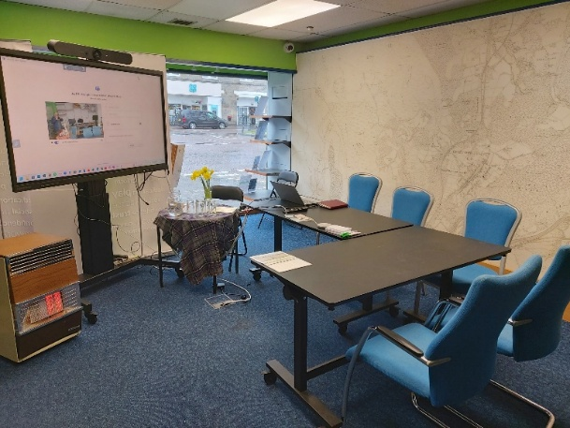
Our early and promising progress towards co-working and internet meetings was dealt a hammer blow with the loss of all our digital services.

However, by the end of May, we had negotiated an excellent contract with Highland Broadband,

Promoting Grantown

The Hub’s many offers, displays and events have provided a significant and positive element to the High Street, making it a more attractive destination. Local arts and crafts workers have items on show, both promoting and selling their products. Window displays advertising shops and clubs attract considerable interest and encourage more people to enjoy the variety of shops in the street and visit places and events promoted.

3. Activities and Achievements
There have been many highlights and successes during the year across all five strands of our work: community; business; culture; heritage; health and wellbeing.
“Fantastic to see the space being used and contribute to the town.” (Jane Brown)
Community.
The Hub is becoming seen as the “GO TO” place for information, both for locals and tourists – from bus times and public toilet availability to house histories and way-marked trails - from displays of posters and internet access, supplementing what our volunteers provide – from lost cats and car boot sales to job vacancies and education opportunities.
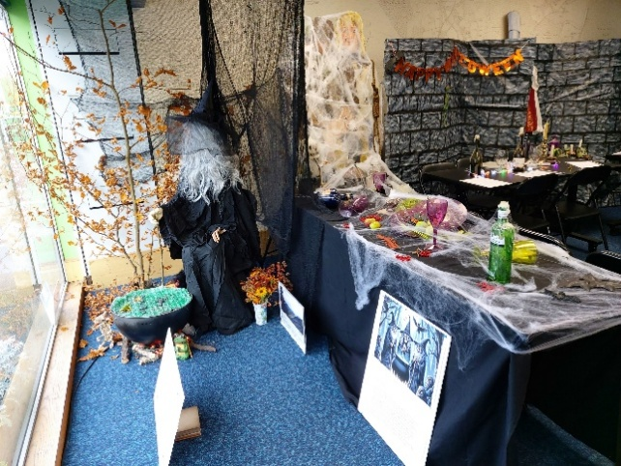
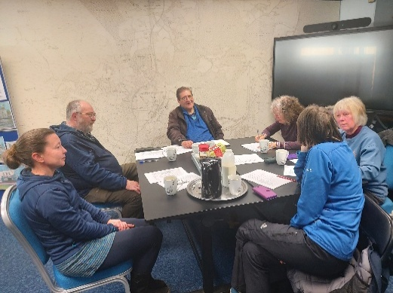
The concept of the Hub as an egalitarian “third space” - somewhere beyond home and work where people can meet and socialise informally – is slowly becoming a practical reality. This has been fostered by access to resources and themed events and displays for such as Holodimor Day, Hallowe’en, football, shinty and cycling promotions as well as an ever-ready supply of tea and coffee and wine on occasions.

As yet, little progress has been made on the planned coming events digital display in the window.
Our ATM, replacing two lost when banks closed became our most loved addition.
Business.
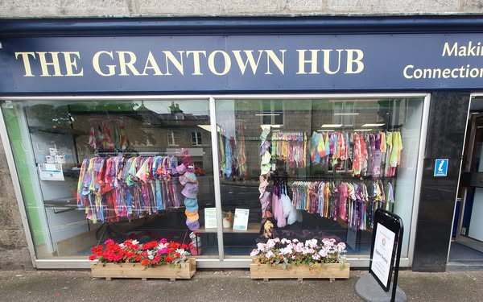
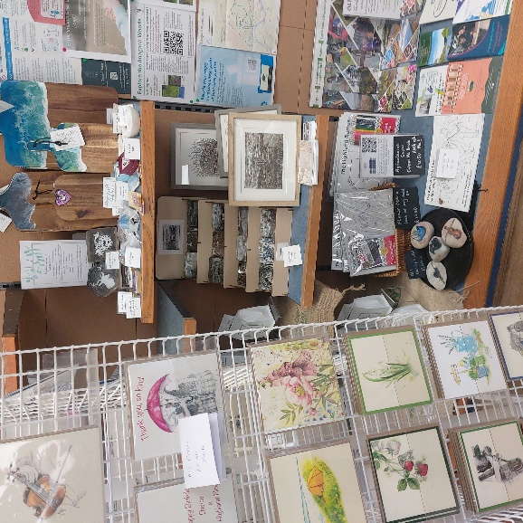
The Hub has been able to provide shelf space for promotions and sales for local arts and crafts workers. The Business area at times became a pop-up shop, famously for the “stick man”. the glass partition when fitted, greatly enhanced provision.

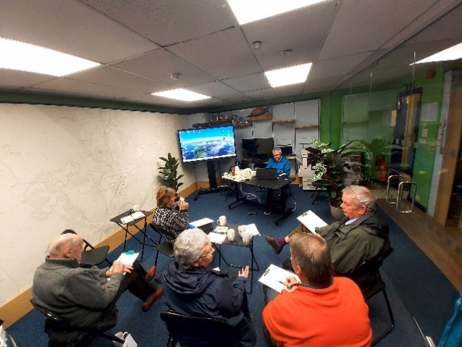
The “Internet Lounge” was becoming the meeting and social space we had envisaged. With funding from the place-based inclusion project we were able to fit out the space to a high standard and it was beginning to be used for hot desking and online meetings, in line with our remit to minimise digital exclusion, which is becoming a massive issue especially in rural areas
To help, we ran a series of 8 evening workshops. Our hard copy information was another step towards minimising exclusion for those who could not or would not use Facebook. We were generously supported by the business community, who supplied a copier and further hardware. Printing copies of photos downloaded from a mobile became one of the main demands. Security was frequently a problem raised at the help desk.
Our early and promising progress towards co-working and internet meetings was dealt a hammer blow with the loss of our Broadband in March with the collapse of Rapier systems. Shortly after this the originator of the Hub website blocked access to this and to the associated Facebook pages. This, not only lost us our social media voice and a great deal of on-line information, it delayed significantly our progress to the provision of and access to online information. It also resulted in much hard work rectifying the situation and rebuilding local trust. At around the same time, we lost our Microsoft charity version of Office, several income generating programmes of activity, our development contractor and our IT volunteer.
Culture
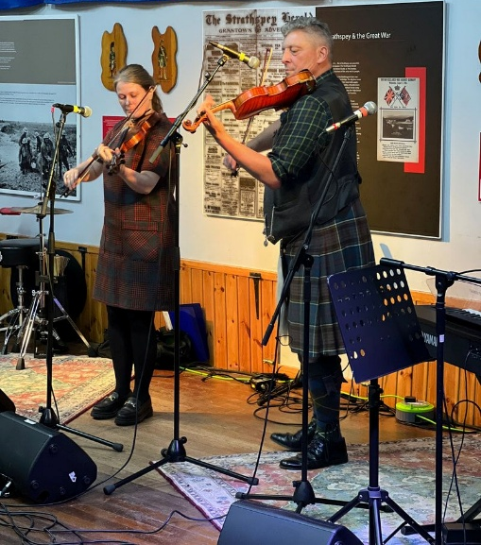
The Society’s contribution to the culture of Strathspey is currently largely focused on traditional music. This year, two music festivals were staged with the Fiddler of Strathspey in September and Strathfest in the Spring. Both were highly acclaimed and due in no small part to the work of a small group of dedicated volunteers and again the support of Paul Anderson, Scotland’s foremost traditional fiddler. The Society is supporting monthly tutorials and workshops run by Paul, followed by Bar sessions in the Ben Mhor Hotel.
Other music events have involved members of the Cairngorm Orchestra and world-renowned composer and pianist Dmitro Morykit. We also ran a poetry competition with £250 prize money donated. It linked to a poetry reading evening in the Speyside Hotel and an evening presentation, “A poetic walk along the Spey.
Health and Wellbeing.
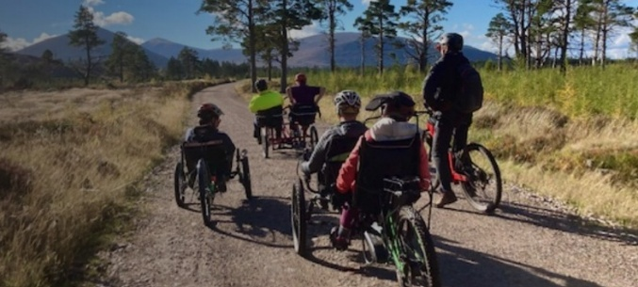
Several NHS Near Me sessions were held using the Hub’s private office space. Whilst these provided no income and created some logistical problems, it was felt the work was worthwhile as a valuable service for the community. The 3As active travel project, which has been a major Society project, reached (almost) its stage two conclusion and is now within the CNPA remit. Following this and in association with CNPA and local cycle groups, a very successful festival of cycling was run around Easter time. www.wheelsaroundgrantown.org.uk The Hub advertises and promotes local walks, which are occasionally led by the Society and some can be found on the Society Website www.thegrantownsociety.org Discussions have ow been initiated by the Society on a ”Grantown Growing Together” community network.
Heritage.
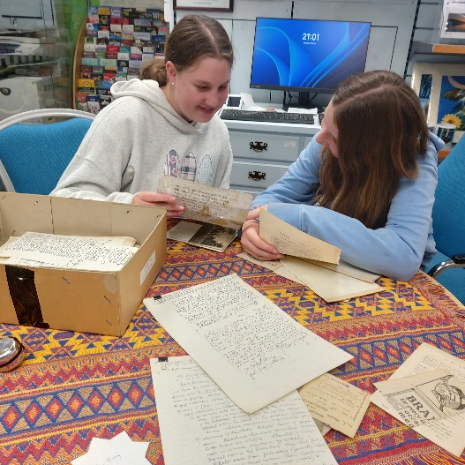
The Grantown society was founded in 1974 in order to collect and record information about the town to celebrate, promote and develop the area’s unique heritage. In the intervening fifty years, it has grown in size and reach. Its members have collected a large amount of information and with the opening of the Hub, some at least of this found, at last, a permanent home. By far the largest collection was that of its founder, George Dixon MA Bsc FSA SCOT, an archivist and Grantown’s historian. With his death in October 2024 at the age of 88, his collection was gradually brought to Grantown and is currently being sorted and archived, a process which will take many years. Several of our displays represented a historic theme, such as during the festival of cycling in April and our model railway fortnight in October.
“A lovely surprise to find a mini pop-up bicycle museum in Grantown. What a great resource this Hub is.” (Bob Johnstone)
During this year material from the “Grantown Collection” has been used for displays and for some research.
These resources are, and always have been, invaluable for the Society walks and winter talks. The year's programme, with several distinguished speakers, covered: “The Strathspey” with Paul Anderson; A poetic journey, along the Spey; The Picts in Strathspey; The Enigma of Abbe Peter Grant; Who owns Strathspey: and Salmon fishing and Fly tying. Through the Hub various research projects have been carried out and further papers, photographs and ephemera collected.

4. Volunteer and Community Involvement
The Grantown Society is a partnership organisation and has a record of working with many and diverse partners, whether the football club or the museum, individual shops or the Business Association. The Hub, as the Society’s home and focus for its work, is community-led, and the business plan was created with reference to community wishes. The digital inclusion project is in association with The YM Community Centre, the Remakery and the Strathspey and Badenoch inclusion partnership which the Society initiated. The Hub Log and Visitors’ books record community activities and visitors’ comments and influence decision-making at Board Level. The Society membership is currently at £10 for life and an annual “Club” membership has been introduced at £25 pa. Membership in June stood at around 170. The ongoing work is carried out by a team of volunteers, which includes those who regularly host Hub open sessions, to those who sell raffle tickets at events. These numbers total around 25. For 10 months of the 24/25 year, SLF paid for a part-time development contractor. The first left in April ’24 to move South, and a replacement was recruited.
5. Financial Overview
[the audited report will be available prior to the AGM.] The cash balance at the end of June was £25,700 which includes both restricted and unrestricted payments and expenses.
6. Governance and Structure
The Trust Board consists of up to 9 annually elected members. For the 24/25 year. During the year one trustee resigned and decided not to re-stand and James Ogilvie-Grant, Viscount Reidhaven accepted the role of Society Patron.
Board meetings were held in August and November 2024, February and June 2025. The AGM was in September 2024. Urgent matters requiring Board approval were made by individual email and personal contact.
The Governance and main policies were re-approved at the AGM and can be found on the Society website.
7. Risk and Future Planning
Risks include Finance, esp revenue for Hub manager and ongoing income generation, digital programme including website and security, volunteer numbers and skill levels, and increasing active community involvement. Future planning will be on board and AGM agendas and will refer to year one progress and year two business plan.
8. Legal and Administrative Details

- The Grantown Society SCIO is a Scottish Charity SC050104
- Registered address 2,4 High Street Grantown-on-Spey
- The Grantown Society was founded in 1974
Ain contact at present is
- Bill Sadler
- Justbill2015@gmail.com
- M: 07709270044
- Murree, Woodside Avenue, Grantown PH26 3JN

- Chairman
- The Grantown Society
- info@thegrantownsociety.org
- www.thegrantownsociety.org

Trustees for the year.
- Bill sadler: chair
- Graeme Stuart: general secretary
- Peter Holland: treasurer
- Bill Steele: membership secretary
- Jenny Steven
- Jo fry
- Hamish Thom
- James Ogilvie-Grant
- Independent examiner or auditor MacKenzie Kerr Limited.
9. Approval and Sign-Off
This report was approved by the trustees on August 23 2025
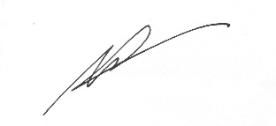
and signed on their behalf by:
Chair of Trustees. William Sadler
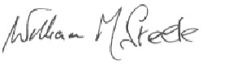Membership Secretary William Murray Steele

